Assignment by Dewal Bhandari
BCA 3rd Semester
Project: Dev Kiran Bijuli Pasal
Subject: Web Technologies I

Site Map:
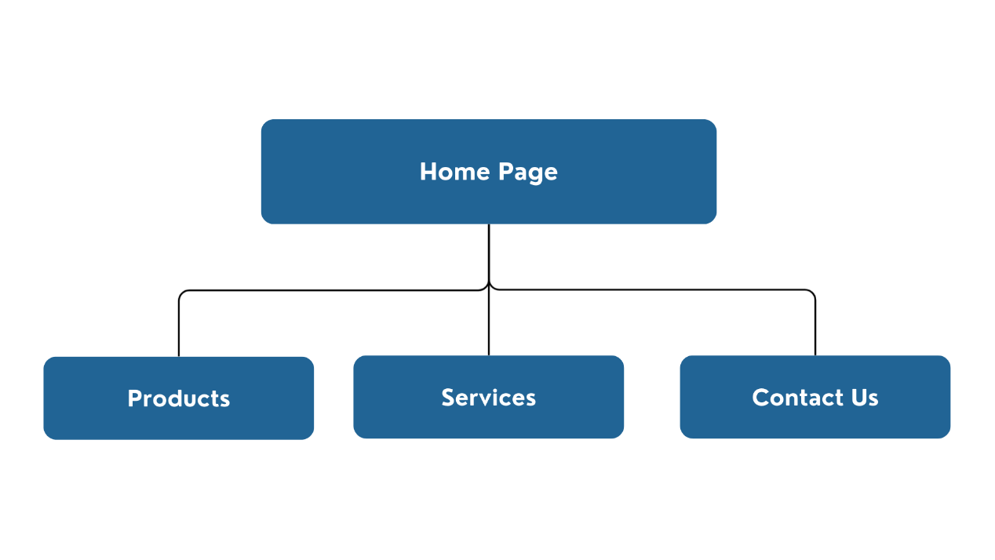

References used: Canva,
Pictures: Google

Github : https://github.com/Dewal-27/Web-Assignment

ScreenShort of HTML validation Results: